EE5355_DISCRETE TRANSFORMS AND APPLICATIONS

ASSIGNMENT 2D MIRRORING

NAME: PAVAI ARCHIMEDES

ST ID:1001233996

PROGRAM:

clc;

close all;

clear all;

I=imread('C:\Users\PAVAI ARCHIMEDES\Desktop\lena512.bmp');

figure (1);

subplot(2,3,1);

imshow(I);

title('Original Lena Image');

H=diag([1,-1,1,-1,1,-1,1,-1]);

end2=377;

for i=1:8:512

end1=377;

for j=1:8:512

I_dct_88=dct2(I(i:i+7,j:j+7));

if(i>128 && j>128 &&i<=384 && j<=384)

I_dct=I_dct_88*H;

I_H(i:i+7,end1:end1+7)=(idct2(I_dct));

I_dct_88=H*I_dct_88;

I_H_V(end2:end2+7,j:j+7)=(idct2(I_dct_88));

I_dct_88_90=I_dct_88'*H;

I_H_90(j:j+7,end2:end2+7)=(idct2(I_dct_88_90));

I_dct_88_270=H*I_dct_88';

I_H_270(end1:end1+7,i:i+7)=(idct2(I_dct_88_270));

I_dct_88_180=H*I_dct_88*H;

I_H_180(end2:end2+7,end1:end1+7)=(idct2(I_dct_88_180));

end1=end1-8;

else

I_H(i:i+7,j:j+7)=idct2(I_dct_88);

I_H_V(i:i+7,j:j+7)=idct2(I_dct_88);

I_H_90(i:i+7,j:j+7)=idct2(I_dct_88);

I_H_270(i:i+7,j:j+7)=idct2(I_dct_88);

I_H_180(i:i+7,j:j+7)=idct2(I_dct_88);

end

end

if(i>128 &&i<384)

end2=end2-8;

end

end

subplot(2,3,2);imshow(I_H,[0 255]);title('Horizontal Mirror');

subplot(2,3,3);imshow(I_H_V,[0 255]);title('Vertical Mirror');

subplot(2,3,4);imshow(I_H_90,[0 255]);title('90 Rotation');

subplot(2,3,5);imshow(I_H_270,[0 255]);title('270 Rotation');

subplot(2,3,6);imshow(I_H_180,[0 255]);title('180 Rotation');

figure (2); subplot(2,3,1);imshow(I);title('Original Lena Image');

H=diag([1,-1,1,-1,1,-1,1,-1,1,-1,1,-1,1,-1,1,-1]);

end2=369;

for i=1:16:512

end1=369;

for j=1:16:512

I_dct_1616=dct2(I(i:i+15,j:j+15));

if(i>128 && j>128 &&i<=384 && j<=384)

I_dct_1616_H=I_dct_1616*H;

I_H_M_16(i:i+15,end1:end1+15)=(idct2(I_dct_1616_H));

I_dct_1616_V=H*I_dct_1616;

I_H_V_16(end2:end2+15,j:j+15)=(idct2(I_dct_1616_V));

I_dct_1616_90=I_dct_1616'*H;

I_H_90_16(j:j+15,end2:end2+15)=(idct2(I_dct_1616_90));

I_dct_1616_270=H*I_dct_1616';

I_H_270_16(end1:end1+15,i:i+15)=(idct2(I_dct_1616_270));

I_dct_1616_180=H*I_dct_1616*H;

I_H_180_16(end2:end2+15,end1:end1+15)=(idct2(I_dct_1616_180));

end1=end1-16;

else

I_H_M_16(i:i+15,j:j+15)=idct2(I_dct_1616);

I_H_V_16(i:i+15,j:j+15)=idct2(I_dct_1616);

I_H_90_16(i:i+15,j:j+15)=idct2(I_dct_1616);

I_H_270_16(i:i+15,j:j+15)=idct2(I_dct_1616);

I_H_180_16(i:i+15,j:j+15)=idct2(I_dct_1616);

end

end

if(i>128 &&i<384)

end2=end2-16;

end

end

subplot(2,3,2);imshow(I_H_M_16,[0 255]);title('Horizontal Mirror');

subplot(2,3,3);imshow(I_H_V_16,[0 255]);title('Vertical Mirror');

subplot(2,3,4);imshow(I_H_90_16,[0 255]);title('90 Rotation');

subplot(2,3,5);imshow(I_H_270_16,[0 255]);title('270 Rotation');

subplot(2,3,6);imshow(I_H_180_16,[0 255]);title('180 Rotation');

OUTPUT:

FOR (8x8):

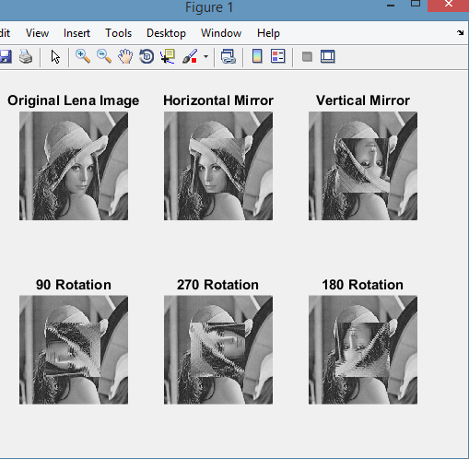

FOR(16X16):

